Topic: Memorandum of Understanding Renewal for Kenai River Baseline Water Quality Monitoring

[Date]

Dear NAME,

The Kenai River Baseline Water Quality Monitoring program is one of Alaska’s longest-running and most robust efforts to assess water quality in the state. Since the year 2000 the program has partnered with over a dozen government, tribal, private, and non-governmental organizations. Results have provided critical data for management decisions at the local level that help keep the Kenai River both accessible and healthy.

The project’s Memorandum of Understanding (MOU) document outlines the roles of partnering organizations, and is due for renewal. We are requesting a renewal signature from your office as confirmation of continued support for this project. The MOU is a non-binding document and does not legally commit any entities or individuals to financial support or management actions.

We are eager to share more about the project with your office and look forward to speaking with you. Additional details and resources are linked on the project [website](https://www.kenaiwatershed.org/kenai-river-baseline-water-quality-monitoring/), as well as in the Project Status Summary attached here.

Thank you for your support and consideration. Sincerely,

[Signature]

Benjamin Meyer  
Water Quality Coordinator  
[ben@kenaiwatershed.org](mailto:ben@kenaiwatershed.org)   
(907) 232-0280

[Signature]

Trent Dodson  
Executive Director  
[executivedirector@kenaiwatershed.org](mailto:executivedirector@kenaiwatershed.org)   
(907) 260-5449 ext. 1206

Attached Documents:

1. Past MOU Signatories
2. 2024 Memorandum of Understanding
3. Signature Page
4. Project Status Summary

**Attachment A: Past Signatories for the Kenai River Baseline Water Quality Monitoring Project Memorandum of Understanding**

2015 MOU Signers (most recent)

* Commissioner, Alaska Department of Environmental Conservation
* Commissioner, Alaska Department of Fish and Game
* Commissioner, Alaska Department of Natural Resources
* Principal, Analytica, Inc.
* Mayor, City of Kenai
* Mayor, City of Soldotna
* Executive Director, Cook Inlet Aquaculture Association
* Mayor, Kenai Peninsula Borough
* Executive Director, Kenaitze Indian Tribe
* Executive Director, Kenai Watershed Forum
* Alaska Regional Director, U.S. Fish and Wildlife Service
* Forest Supervisor, Chugach National Forest

**Attachment B: 2024 Memorandum of Understanding**

*Draft: see document in same folder*

**Attachment C: Signature Page**

*Draft: see document in same folder*

**Attachment D: Project Status Summary**

**November 2024**

**The Kenai River Baseline Water Quality Monitoring Project – 24 years of Community Driven Research**

***Introduction***

The Kenai River in southcentral Alaska is among the world’s most famed, supporting diverse fisheries and industries and the people who rely on them. Since the year 2000 [Kenai Watershed Forum](https://www.kenaiwatershed.org/) has coordinated the efforts of government, tribal, private, and nonprofit partners to monitor water quality trends throughout the river as specified in the Alaska Department of Natural Resources’ 1997 [Kenai River Special Management Area Comprehensive Management Plan](https://dnr.alaska.gov/parks/plans/krsmapln/kenrvpln.htm). The twenty-four year continuous effort has produced a long and robust water quality dataset that is applied to identify and address critical local water management issues. The program serves as a remarkable example of how community partnerships can generate outsized impact.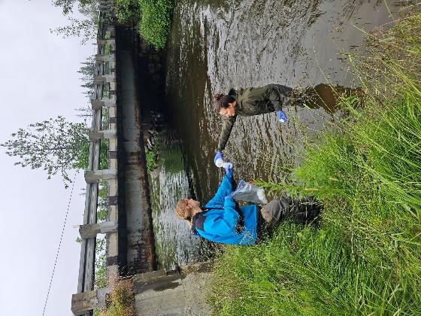

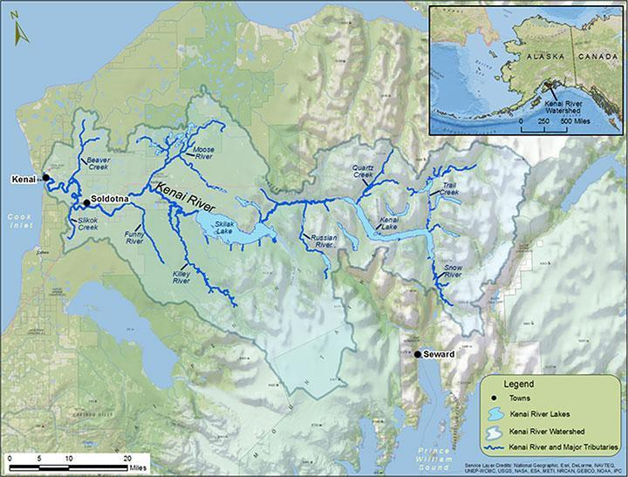

Twice annually, we measure water quality at twenty-two sites throughout the Kenai River and its tributaries. We monitor for a diverse list of substances including bacteria, metals, nutrients, fuels, and more. All results are available in the public domain and are assessed against state and federal water quality standards. Comprehensive reports have been published in 2007 and 2016, with another planned for publication in 2025. Visit the [project website](https://www.kenaiwatershed.org/kenai-river-baseline-water-quality-monitoring/) for details and additional resources.

*Map of the Kenai River watershed in southcentral Alaska (*[*click link for online interactive version*](https://www.arcgis.com/home/webmap/viewer.html?webmap=d4b8b5150bcd47af827fc16630a7a05d&extent=-152.4449,59.7542,-146.7265,61.3972)*)*

***Project Funding and Inflation***

Over fifteen organizations support this work each year with in-kind and/or financial backing. While the overall level of annual financial contribution has remained relatively steady, a *56% rise in inflation* since 2005 has considerably lessened the value of resources available to the project. In 2022 one-time contribution of EPA pass-through funds from Kenaitze Indian Tribe allowed the project to continue as planned through 2024, but future years will need to identify additional funds to continue providing the same level of service.

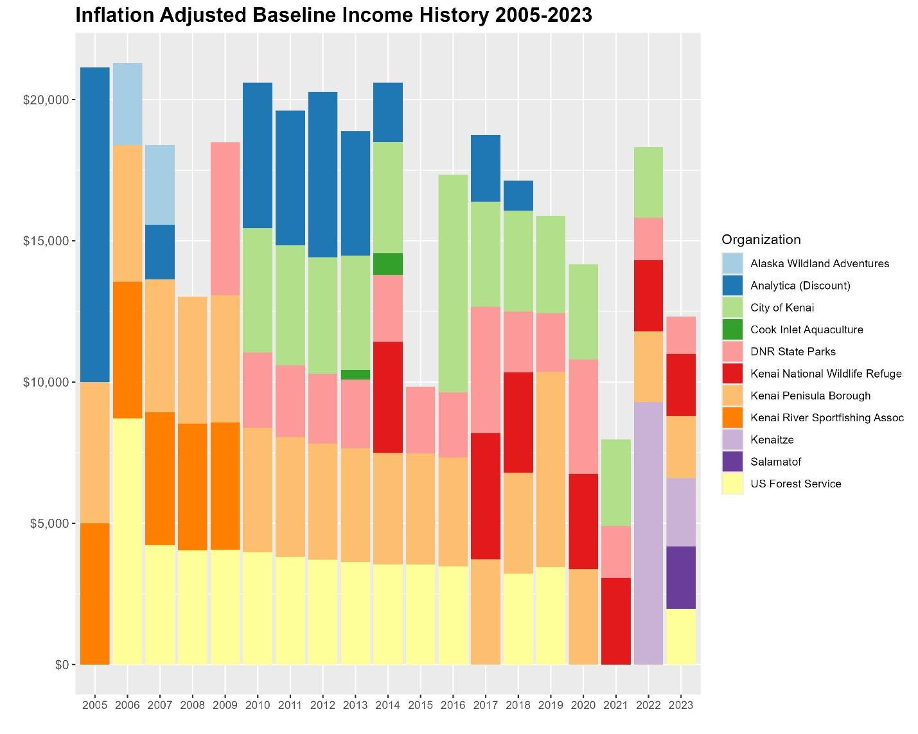

*Inflation-adjusted financial contribution to the Kenai River Baseline Water Quality Monitoring Project 2005 - 2023.*

***Sustaining Future Project Activities***

Kenai Watershed Forum is actively pursuing funding from new public and private sources to support this work, including the U.S. Bureau of Restoration and the ConocoPhillips Community Grants program. However, annual support from existing long-term local partners remains the most viable way to secure this project into the future. As of 2024, annual project income no longer supports base level expenses. Additional details addressing annual project expenses and project results are available upon request.

As your organization considers renewing the Memorandum of Understanding (MOU), the level of annual financial support required to sustain the work will be part of the discussion. *Note that the MOU does not contractually commit any organization to specific financial support.*

We look forward to discussing this work further with your office and are eager to share the next comprehensive report. Thank you for your time and consideration.

***Further Reading and Links***

* Updating Boat Motors Reduces Hydrocarbon Pollution (EPA, 2011)
  + <https://19january2017snapshot.epa.gov/sites/production/files/2015-10/documents/ak_kenai.pdf>
* Kenai River Comprehensive Management Plan (AKDNR, 1997)
  + <https://dnr.alaska.gov/parks/plans/krsmapln/kenrvpln.htm>
* Kenai River Baseline Water Quality Monitoring Project – Homepage (KWF, 2024)
  + <https://www.kenaiwatershed.org/kenai-river-baseline-water-quality-monitoring/>
* Kenai River Baseline Water Quality Monitoring – Presentation to International River Symposium (KWF, 2022)
  + <https://www.youtube.com/watch?v=znROWo6MfAg>

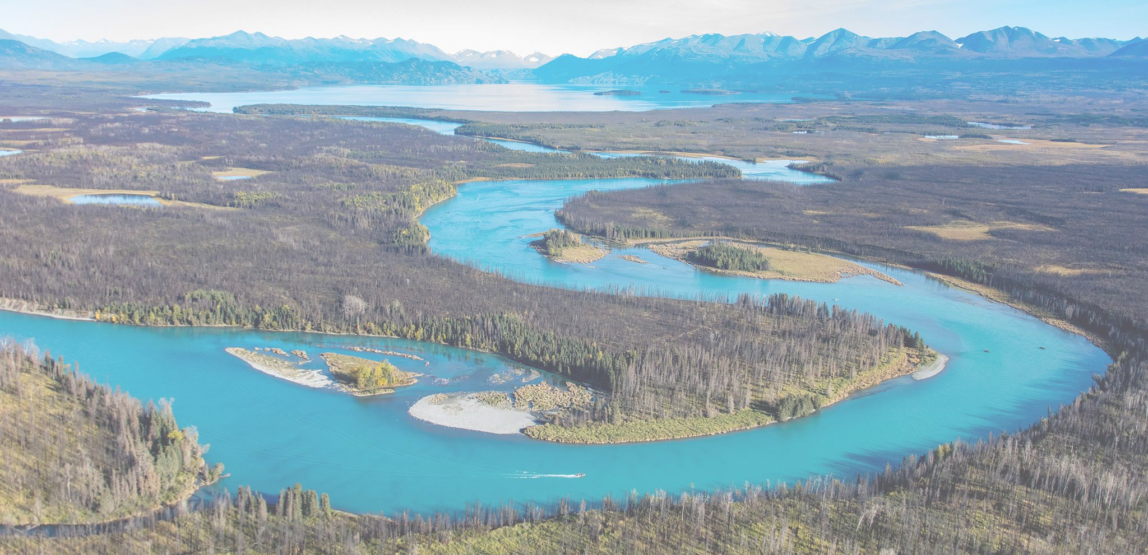

*Photo Credit: Ian Reid*